Guidelines for
GCU’s UNDERGRAD Admission Test and Interview
BA (hons) Political Science (FALL 2021)
Sample Test
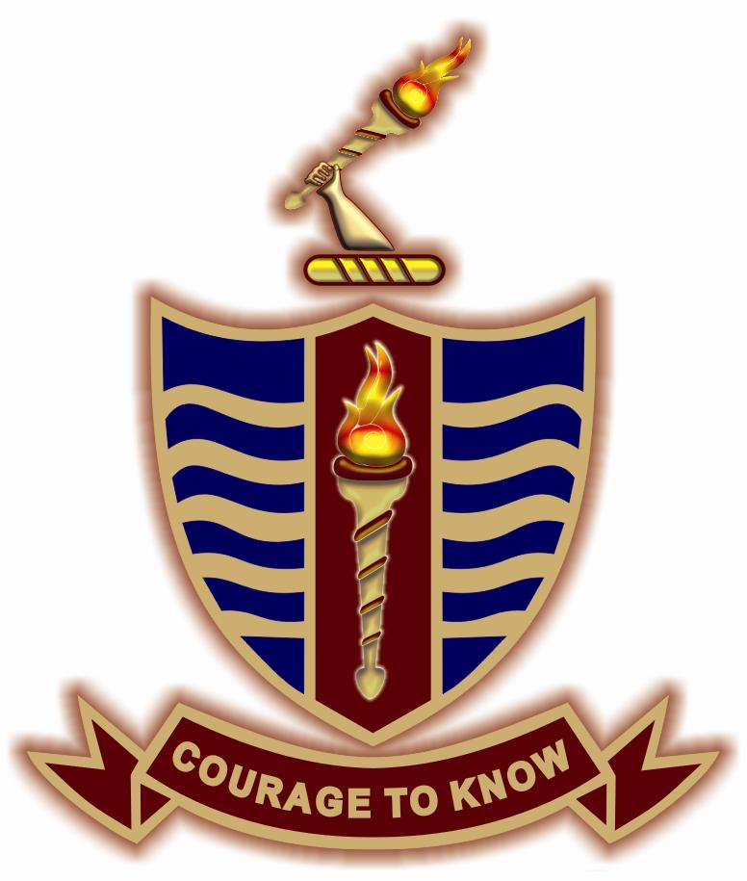

Department of Political Science
Government College University Lahore

Format of Entry Test (Sample Format)
The format of entry test is as follow:
Part A: English Portion
Total marks: 10
Format: 20 MCQs (0.5 marks each)
Time allowed: (30 minutes)
- Reading and comprehension
- Antonyms and Synonyms
- Related Pair of Words
- One Word Substitutes
- Prepositions
- Vocabulary

Part B
Total Marks 10
Format: 20 MCQs (0.5 marks each)
Time allowed: 20 minutes
- Pakistan studies
- Current affairs

Part C
Total Marks 10 (5+5)
Format: essay type (short notes)
Time allowed: 40 minutes
- A total of four questions will be given in this section
- Candidates will have to attempt two questions out of four
- Each question carry five marks each

G C University Lahore
Department of Political Science
BA (Hon) Entry Test

Caution: Following objective and subjective questions are for sample only to help students understand the format of written test.

Name----------------------------------- Father’s Name--------------------------------

Form No-------------------------------- Serial No----------------------------------------

Part A: English Portion
Total marks: 10
Format: 20 MCQs (0.5 marks each)
Time allowed: (30 minutes)
- Reading and comprehension
- Antonyms and Synonyms
- Related Pair of Words
- One Word Substitutes
- Prepositions
- Vocabulary

Part B
Total Marks: 10 (20 MCQs, 0.5 marks each)
Time Allowed: 20 mins

Note; encircle the most appropriate answer only, over writing and cutting will not be entertained.

1) Which document was firstly drafted to give pace to constitution making process?
a) Representative act,
b) Pakistan Act,
c) Independence Act
d) Objective Resolution
2) What was the official language declared in 1956 constitution?
a) Urdu
b) Bengali
c) English
d) Urdu and Bengali
3) Who elects the president according to 1973 constitution?
a) National assembly
b) Senate
c) Provincial Assemblies
d) all of them
4) Sadqain is famous for?
a) Painting
b) Calligraphy
c) Music
d) Painting and Calligraphy
5) Which is the largest source of drinking water for Islamabad?
a) Khanpur Dam
b) Rawal Dam
c) Ghazi Dam
d) Haru Dam
6) Which is National language of AJ & K?
a) Urdu
b) Kashmiri
c) Punjabi
d) Hindko
7) Which is the largest desert of Pakistan?
a) Thal
b) Thar
c) Cholistan
d) None
8) Which of the following women participated in all three Round Table Conferences?
a) Beghum Jahan Ara
b) Beghum Shaista
c) Beghum Salma tasaduq
d) Beghum Qazi
9) Which is the highest building of Pakistan?
a) Headquarter of MCB
b) Pakistan Stock Exchange
c) Icon Tower
d) HBL
10) In which year Cabinet Mission came to India?
a) 1941
b) 1943
c) 1946
d) 1949
11) The book “Khutbat e Ahmadia” is written by?
a) Dr safdar Mahmood
b) Abdul Haleem Sharar
c) Sir Syed Ahmad
d) Syed Amir Din
12) Which state was attacked by India on 11th September 1948?
a) Hyderabad Deccan
b) Jammu & Kashmir
c) Manavadar
d) Junagarh
13) Name of range which separates China from Pakistan?
a) Hindu Kush
b) Pamir
c) Himalayas
d) Karakoram
14) Which of the following mountain peaks is called Killer Mountain?
a) Nanga Parbat
b) Godwin Austin
c) Broad Peak
c) Raka Poshi
15) Shawala Teja Singh Temple is reopened after 12 year. It is located in which city of Pakistan?
a) Multan,
b)Sialkot,
c) Faisalabad,
d) Shekupura
16) Who was the current chairman senate in Pakistan?
a) Hasil bazinjo,
b)Raza Rabbani,)
c) Sadiq Sanjarnai
d)Mehmood Achakzai

17) When did the first General assembly elections in FATA held?
a) 25th July 2019,
b) 20th July 2019,
c) 18th July 2019,
d) 21st July 2019
18) Which country was the largest importer of the weapons in the world during 2014-18?
a) USA,
b) Saudi Arab,
c) China,
d) Russia
19) Who was the first governor general of Pakistan?
a) Khawaja Nazim-u-Deen
b) Quiad-e-Azam M. Ali Jinnah
c) Liaqat Ali Khan
d) M. Ali Bogra

20) In which year Nehru Report was passed?
a) 1927
b) 1928
c) 1929
d) 1930

Part C
Time Allowed: 40 minutes
Marks: 10 (5+5=10)
Attempt any two questions. Each question carry 5 marks.
Sample Questions
Q1: What are the main obstacles for the establishment of a real democratic system in Pakistan?
Q2: Which are the most significant differences in the constitution of 1962 and 1973?
Q3: Explain bilateral relations between Pakistan and Afghanistan.
Q4: What do you know about water crisis in Pakistan? Also suggest concrete steps for its solution.

