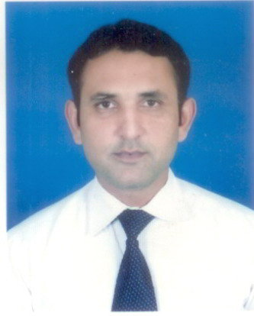

Abdul Aijaz

MPhil History, MA. English, MSc. Political Studies
Personal Information | Father’s Name Allah Yar Khan  Postal Address 134/R, Model Town, Lahore.  NIC No. 35301-9453042-9  Date of Birth 11th October, 1981  Phone Number 0333-4166255  Email ijazppk@hotmail.com  Nationality Pakistani
Academic Qualification | Degree | Institution
 | MPhil. History | GC University, Lahore (2009-2011)
 | MSc. Political Studies | Quaid-e-Azam University, Islamabad (2003-2005)
 | M.A. English Literature | University of the Punjab, Lahore (2001-2003)
Computer Skills | ● Internet ● Office XP (Word, Excel, etc)
Languages | - English (S.R.W), Urdu (S.R.W)  - Punjabi (S.R.W), Saraiki (S)
Professional History | - Lecturer in Political Science, GC University, Lahore 2007 to Date.  - Lecturer in English, Govt. Degree College, Phool Nagar, Kasur (2005-2007).  - Assistant Editor. The Journal of Political Science, Department of Political Science, GCU, Lahore.  - Assistant Editor, Disaster Alert, RDPI, Islamabad (2004-2005).  - Teaching Assignment of Political Science, Competitors Academy for CSS.  - Programme Coordinator, AAPI, Islamabad, 2004.
Professional Trainings  &  Workshops | - Teacher’s Training organized by HEC in GCU, Lahore  - Participatory Methodology, Organized by RDPI, Islamabad.  - Active Citizen Training Programme, organized by British Council, Pakistan.  - Workshop on Testing Methods organized by GCU, Lahore  - Workshop on Mobilizing Community organized by AAPI, Islamabad.
Seminars  &  Conferences | - State of Social Sciences in Pakistan, organized by Department of History, GCU, Lahore  - War on Terrorism and its implication for Pakistan, Department of Political Science, University, of the Punjab, Lahore  - Confidence Building Measures: A reprisal of India-Pakistan Relations, NIPS, Quaid-e-Azam University, Islamabad  - Conference on American History, ASC, Quaid-e-Azam University, Islamabad  - Extremism in Pakistan, LUMS, Lahore.  - Literature and Society, Department of English, University of the Punjab, Lahore  - Indo-Pak Relations, CPPG, FC University, Lahore  - Pakistan’s Role in War on Terror, GCU, Lahore  - Pakistan’s Economic Problem, GCU, Lahore
Achievements/  Cocurricular Activities | - Best Teacher Award, GC University, Lahore.  - First Prize in All Pakistan Declamation Contest, Govt. College Chishtian  - Second Prize in All Pakistan Debate Competition, Govt. College, Gojra  - President Dramatic Society, Department of English, PU, Lahore  - Consolation prize in All Pakistan Poetry Competition, Govt. College Gojra
Some Courses Taught | Political Thought Comparative Governments  Concepts of International Relations Political Science Theory  Pakistan Affairs English Literature
Research Area | - Hydropolitics in Pakistan and South Asia  - Political Thought
Membership | - Youth Parliament of Pakistan  - Institute of Peace and Secular Studies

